**Register Car**

@startuml

actor CarOwner

participant "RegisterCarForm" as UI

participant "CarController" as Controller

participant "CarService" as Service

participant "CarRepository" as Repo

CarOwner -> UI : open register form

UI -> CarOwner : display input fields

CarOwner -> UI : submit car data

UI -> Controller : validate input

Controller -> Service : process new car

Service -> Repo : save car

Repo --> Service : confirmation

Service --> Controller : success

Controller --> UI : show success message

UI --> CarOwner : registration complete

@enduml

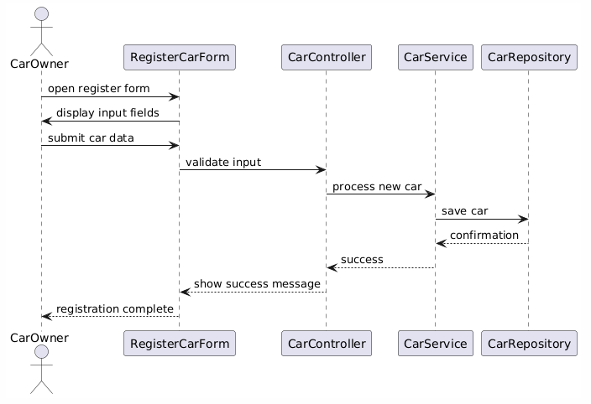

**Update Car Info**

@startuml

actor CarOwner

participant UI

participant CarController

participant CarService

participant CarRepository

CarOwner -> UI : select car to update

UI -> Controller : request car info

Controller -> Service : fetch car by ID

Service -> Repo : find car

Repo --> Service : return car

Service --> Controller : car data

Controller --> UI : show data

CarOwner -> UI : submit updated data

UI -> Controller : validate and submit

Controller -> Service : update car

Service -> Repo : save updated car

Repo --> Service : update OK

Service --> Controller : success

Controller --> UI : show confirmation

@enduml

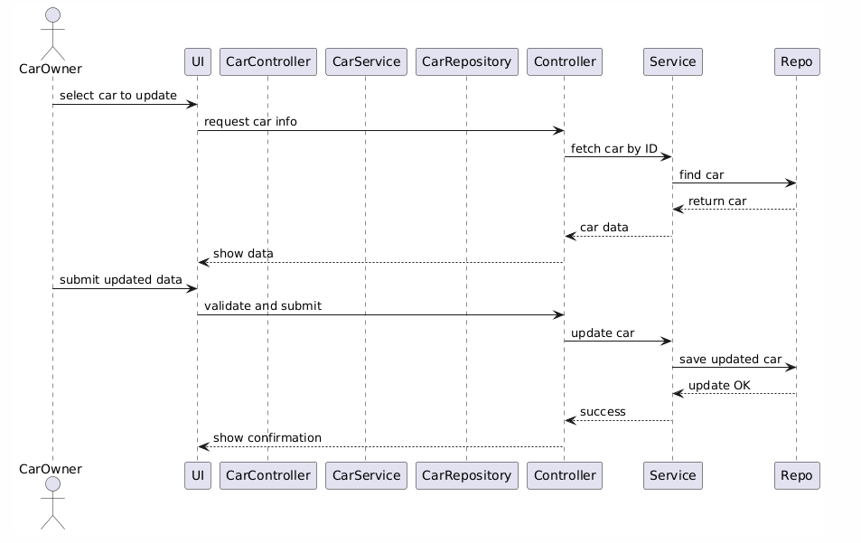

Book Car + Pay for Car

@startuml

actor Renter

participant UI

participant BookingController

participant BookingService

participant CarRepository

participant PaymentService

participant BookingRepository

Renter -> UI : select car + book

UI -> BookingController : request booking

BookingController -> BookingService : create booking

BookingService -> CarRepository : check availability

CarRepository --> BookingService : available

BookingService -> PaymentService : initiate payment

PaymentService -> Renter : ask for card details

Renter -> PaymentService : provide payment info

PaymentService -> PaymentService : charge card

PaymentService --> BookingService : payment OK

BookingService -> BookingRepository : save booking

BookingRepository --> BookingService : confirmation

BookingService --> BookingController : booking OK

BookingController --> UI : show success

UI --> Renter : booking pending approval

@enduml

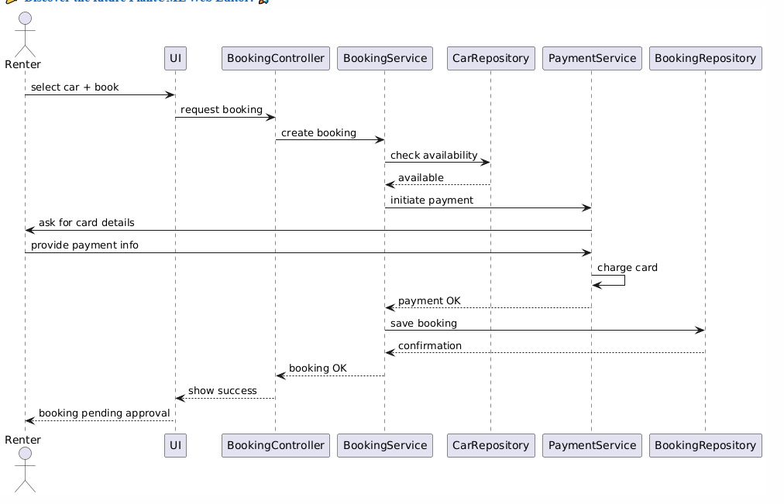

**Approve Booking**

@startuml

actor CarOwner

participant UI

participant BookingController

participant BookingService

participant BookingRepository

participant NotificationService

CarOwner -> UI : view pending bookings

UI -> Controller : get requests

Controller -> Service : fetch pending bookings

Service -> Repo : query pending

Repo --> Service : list

Service --> Controller : return list

Controller --> UI : show list

CarOwner -> UI : approve request

UI -> Controller : confirm approval

Controller -> Service : update status

Service -> Repo : set status = approved

Repo --> Service : success

Service -> NotificationService : notify renter

NotificationService --> Service : notified

Service --> Controller : done

Controller --> UI : show success

@enduml

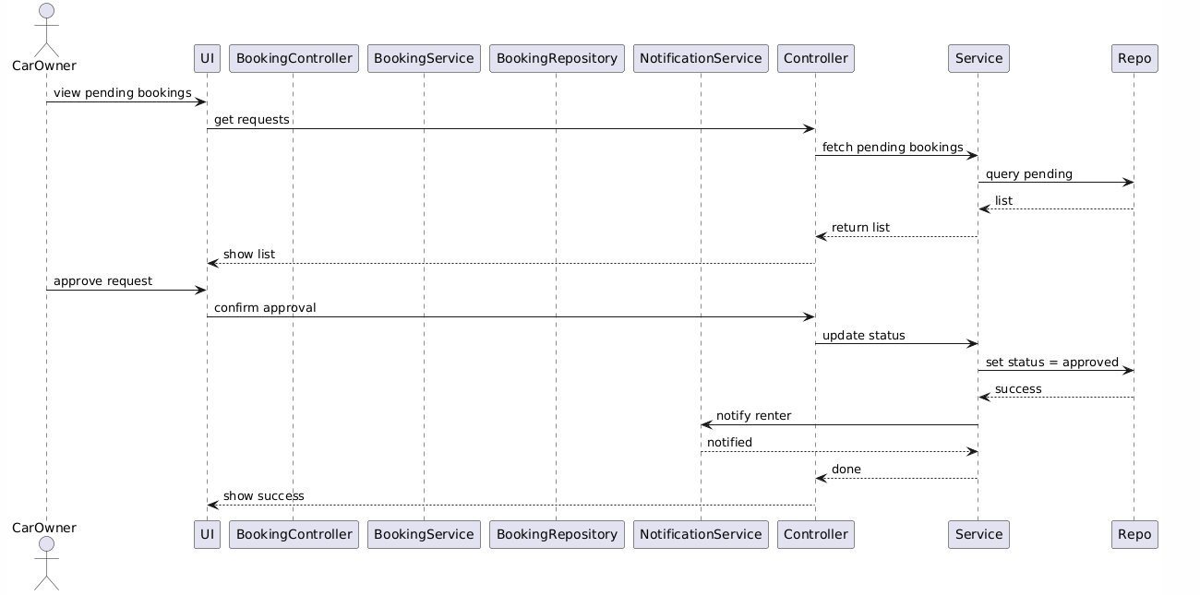

Reject Booking

@startuml

actor CarOwner

participant UI

participant BookingController

participant BookingService

participant BookingRepository

participant NotificationService

CarOwner -> UI : view requests

UI -> Controller : get bookings

Controller -> Service : get pending

Service -> Repo : fetch data

Repo --> Service : list

Service --> Controller : return

Controller --> UI : show options

CarOwner -> UI : reject booking

UI -> Controller : submit rejection

Controller -> Service : update status

Service -> Repo : set status = rejected

Repo --> Service : updated

Service -> NotificationService : notify renter

NotificationService --> Service : done

Service --> Controller : completed

Controller --> UI : show confirmation

@enduml

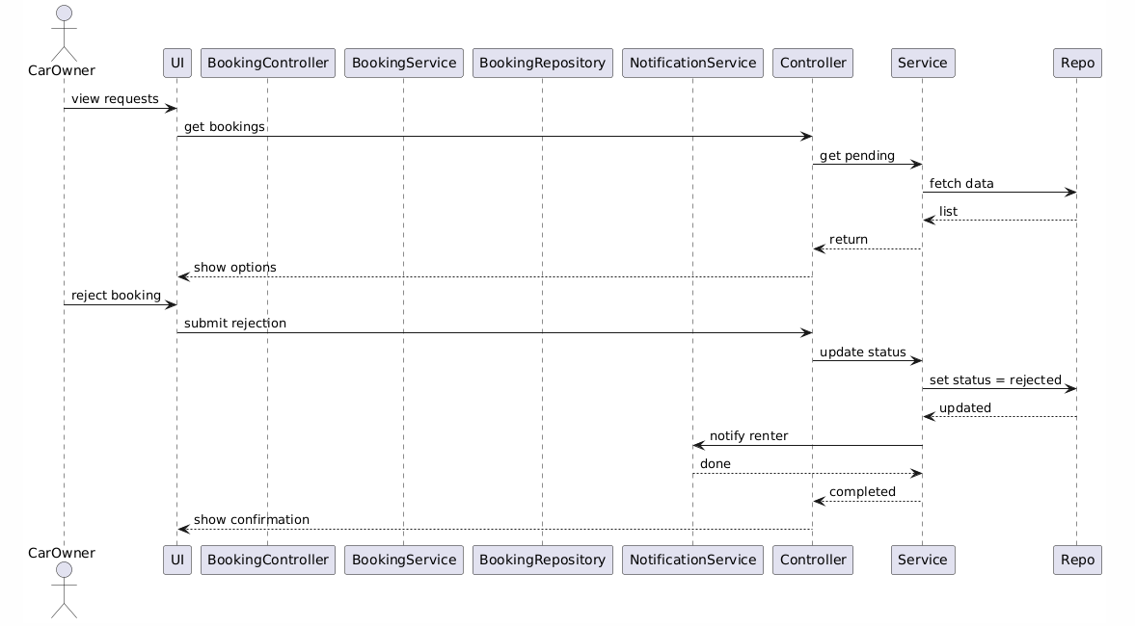

Cancel Booking

@startuml

actor Renter

participant UI

participant BookingController

participant BookingService

participant BookingRepository

participant NotificationService

Renter -> UI : select active booking

UI -> Controller : request cancel

Controller -> Service : check status

Service -> Repo : find booking

Repo --> Service : booking found

Service -> Repo : update to canceled

Repo --> Service : status updated

Service -> NotificationService : inform CarOwner

NotificationService --> Service : sent

Service --> Controller : cancel done

Controller --> UI : show canceled

UI --> Renter : booking canceled

@enduml

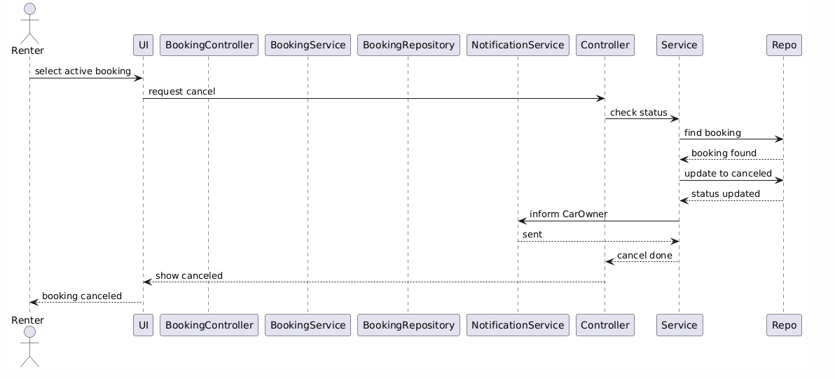

Leave Review

@startuml

actor Renter

participant UI

participant ReviewController

participant ReviewService

participant ReviewRepository

Renter -> UI : leave review

UI -> Controller : submit review data

Controller -> Service : validate + create

Service -> Repo : save review

Repo --> Service : saved

Service --> Controller : done

Controller --> UI : show success

@enduml

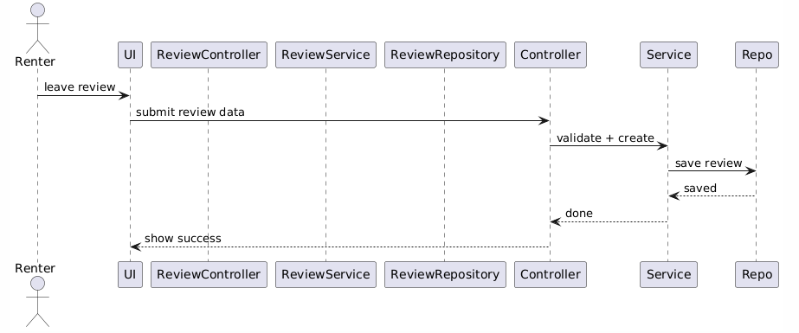

Resolve Dispute

@startuml

actor Renter

actor Admin

participant UI

participant DisputeController

participant DisputeService

participant DisputeRepository

Renter -> UI : open dispute

UI -> Controller : submit dispute

Controller -> Service : create new

Service -> Repo : save dispute

Repo --> Service : saved

Service --> Controller : done

Controller --> UI : show confirmation

Admin -> UI : view disputes

UI -> Controller : get disputes

Controller -> Service : fetch all

Service -> Repo : find disputes

Repo --> Service : list

Service --> Controller : return

Controller --> UI : show list

Admin -> UI : resolve dispute

UI -> Controller : update status

Controller -> Service : resolve

Service -> Repo : update

Repo --> Service : done

Service --> Controller : resolved

Controller --> UI : show resolved

@enduml

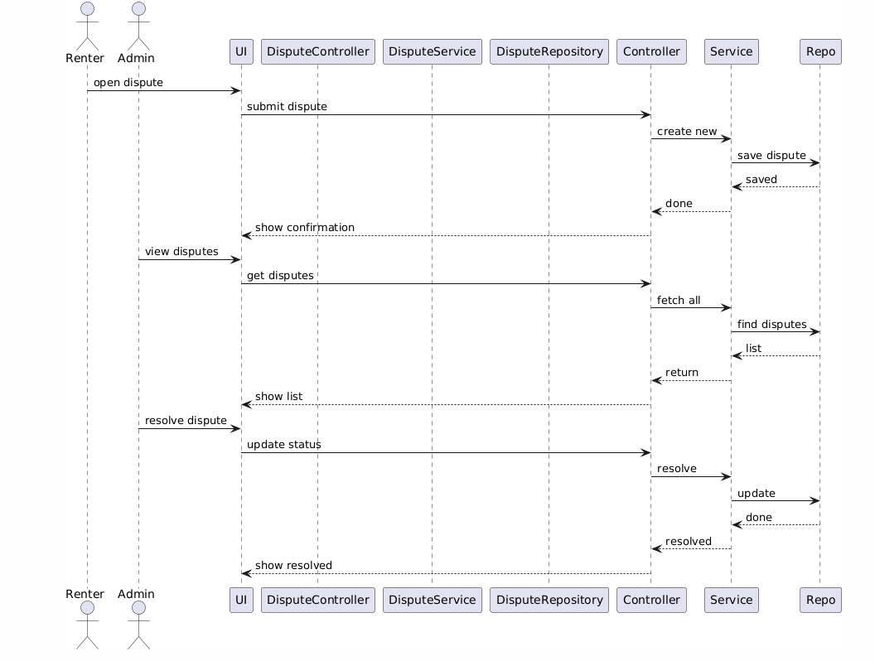

Search Car

@startuml

actor Renter

participant UI

participant CarController

participant CarService

participant CarRepository

Renter -> UI : enter search filters

UI -> Controller : search request

Controller -> Service : process filters

Service -> Repo : query available cars

Repo --> Service : result list

Service --> Controller : filtered cars

Controller --> UI : show cars

UI --> Renter : display results

@enduml

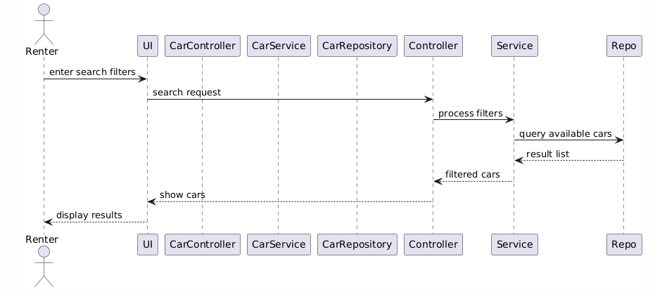

## ****Manage Users & Cars****

## @startuml

## actor Admin

## participant UI

## participant AdminController

## participant UserService

## participant CarService

## participant UserRepository

## participant CarRepository

## Admin -> UI : open management panel

## UI -> Controller : get all users + cars

## Controller -> UserService : get users

## UserService -> UserRepository : find all

## UserRepository --> UserService : user list

## Controller -> CarService : get cars

## CarService -> CarRepository : find all

## CarRepository --> CarService : car list

## Controller --> UI : combined data

## UI --> Admin : show dashboard

## @enduml

## 

## View Reports

## @startuml

## actor Admin

## participant UI

## participant ReportController

## participant ReportService

## participant BookingRepository

## Admin -> UI : open reports

## UI -> Controller : get stats

## Controller -> Service : fetch stats

## Service -> BookingRepository : get data

## BookingRepository --> Service : data set

## Service --> Controller : generate report

## Controller --> UI : show report

## UI --> Admin : display charts/data

## @enduml

## 